27.10.2021г. группа 1ТЭМ 2 подгруппа 1 пара
Дисциплина ОДБ.03 Иностранный язык
Преподаватель Романюта Маргарита Вадимовна
Занятие № 15
Модуль 4 «Earth Alert! »
Тема 4. 3. Tropical Rainforests. Тест по материалу модуля 4
Цели:
• Образовательная – расширение эрудиции студентов, их общего и лингвистического кругозора на основе практического овладения английским языком;
• Практическая–
1. Развитие навыков чтения, устной речи.
2. Совершенствование коммуникативно-познавательной компетенции студентов по теме «Tropical Rainforests».
• Развивающая – развитие языковых, интеллектуальных и познавательных способностей студентов.
• Воспитательная – воспитание у студентов уважительного отношения к окружающей среде.
1.Работа с лексикой
1.1.Прочитайте слова в словаре WL 13 к занятию.
1.2.Запишите в тетрадь слова с транскрипцией.
2.Работа с текстом на стр.77.
2.1. Imagine you are in a tropical rainforest. Describe the scene. What can you see, hear, feel, tast?
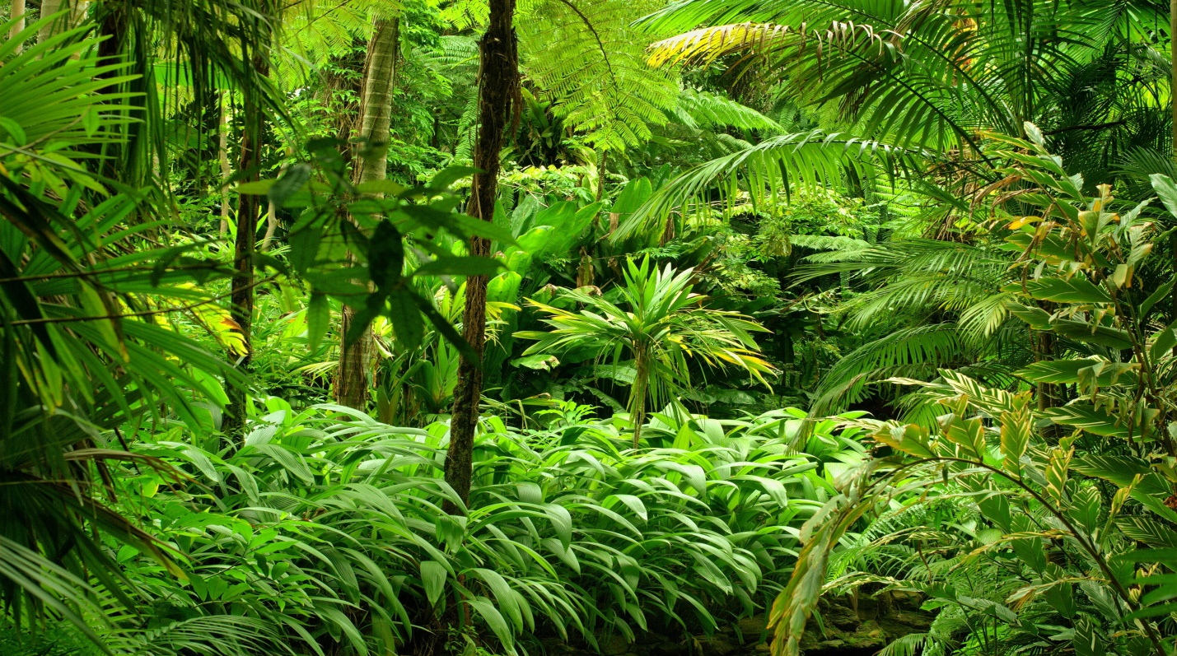
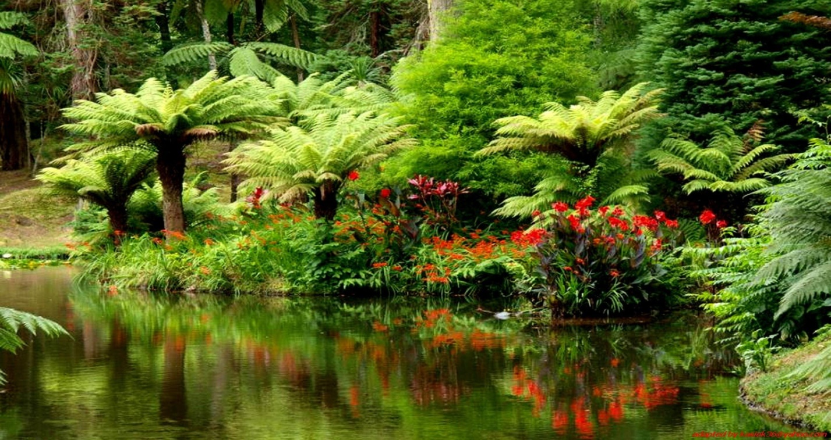
2.2.Read and translate the text «Tropical Rainforests».
What are tropical rainforests?
Tropical rainforests grow in the hot, wet, humid places near the Equator. The plants and trees in the rainforest grow to different heights. The forest can be divided into four layers: the forest floor, the understorey, the canopy and the emergent (layer of larger trees which stick out above all the rest).
Why are they important?
They are important for various reasons. Firstly, they clean and renew the Earth's air supply by absorbing carbon dioxide and producing oxygen. Secondly, they provide a home to thousands of animal and plant species.
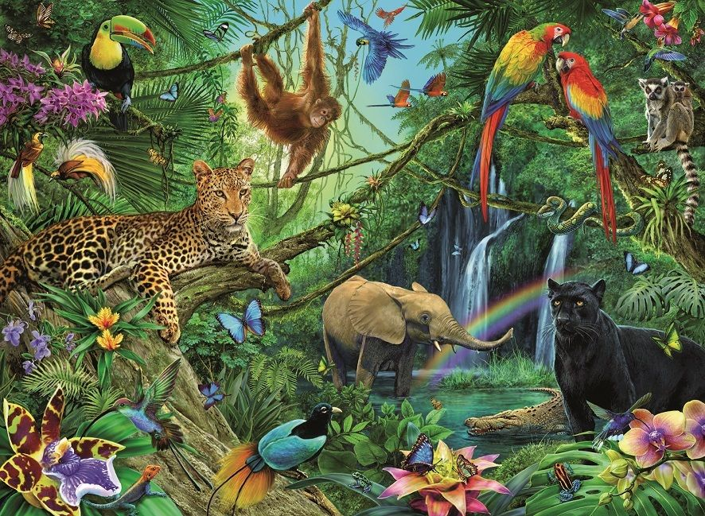
What grows there?
South American rainforests are the home of the wild cocoa plant, from which chocolate is made. The medicines quinine and aspirin come from tree bark and cough mixture is from tree resin, both found in rainforests. Some other important products that come from rainforest plants are mahogany wood, rattan, bananas, paprika, pepper and coffee.
Why are they in danger?
People are destroying the rainforests at a rate of 115 square miles a day. The trees are cut down and used as building material or fuel. The land on which these forests grow is being used for homes and factories and roads.
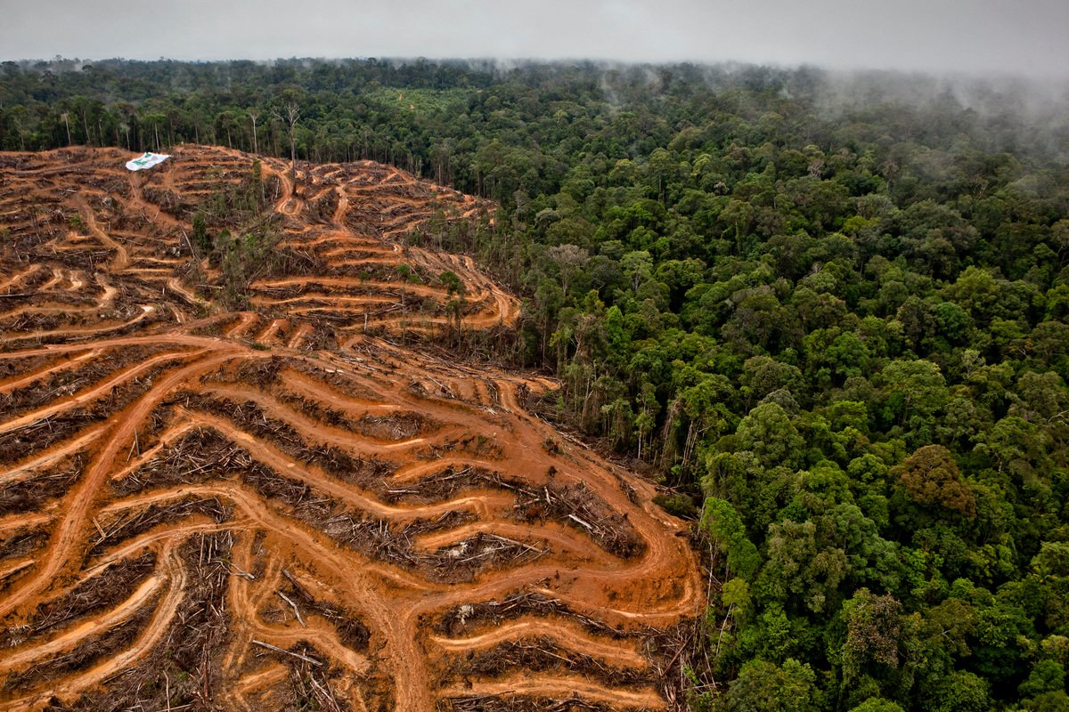
What can we do to save them?
There are lots of things that we can do to help protect the rainforests. Join an organization which tries to save the rainforests, like Greenpeace. Write letters to politicians in countries where there are rainforests, asking them to stop allowing companies to cut down the trees. Don't buy furniture which is produced from rainforest wood.
By acting together, we can really make a difference!
2.3. Answer the questions:
1. Where do tropical rainforests grow?
2. How do tropical rainforests renew the Earth”s air supply?
3. Why are tropical rainforests important to wildlife?
4. Name two medicines that come from trees.
5. Name two ways we can help protect rainforests.
2.4. You belong to an environmental protection organization. Prepare a essay “Save the rainforest”.
3. Упражнение на закрепление грамматической темы : «Модальные глаголы».
3.1. Read the following situations and write how you would respond to each, using modals.
1. Your friend has an awful toothache. What do tell her?
> ... "You ought to see a dentist."...
2. Your friends invite you out but you've got lots of homework. What do you say?
3. You see a sign which reads 'No Swimming' and your friends are getting ready to dive into the water. What do tell them?
4. You see an injured dog on the street on the way home from school. What do you suggest to your friend?
5. The window is open in the classroom and you're cold. What do ask to your teacher?
6. John tells you that Pat failed an exam but you find it hard to believe. How do you reply?
Домашнее задание:
1.Письменно выполнить упражнение 2.3. и 3.1. данного занятия.
2. Выполнить тест по модулю 4. (Vocabulary and Grammar)
Task 1. Choose the correct preposition (ON, OUT, INTO, AWAY, FROM, OVER) to complete each of the following sentences:
- Rodney nearly ran ________ an old lady while he was driving his car.
- Because of global warming, it's very important that we try to stop using cars and other vehicles that run ________ petrol or gasoline.
- We've run ________ of sugar. Could you, please, buy some more?
- We ran ________ your brother at the mall last night.
- We can't run _______ the facts.
Task 2. Use the words from the word bank to fill in the blanks in the text.
Environmental (1) _________ is of a universal concern. That is why serious measures to create a system of (2) _________ security should be taken. Some progress has been already made in this direction. As many as 159 countries - members of the UNO - have set up (3) ___________ protection agencies. Numerous (4) __________ have been held by these agencies to discuss problems (5) __________ ecologically poor regions including the Aral (6) _________, the South Urals, Kuzbass, Donbass, Semipalatinsk and Chernobyl. An international environmental research centre has been set up on Lake Baikal. The (7) __________ organization Greenpeace is also doing much to (8) ___________ the environment. But these are only the initial (9) ______ and they must be carried onward to protect (10) ________, to save life on the planet not only for the sake of the present but (11) _________ for the (12) ________ generations.
steps  preserve  protection | ecological  nature  conferences | international  facing  also | environmental  future  Sea

Task 3. Fill in the blanks with MUST / MUSTN’T / CAN / CAN’T / COULDN’T / HAD TO / DON’T HAVE TO/ SHOULD / SHOULDN’T
- I _________ clean my teeth. I want to be healthy.
- We ________ go to the seaside at last. Our holidays start next week.
- You ________ smoke so much. It's bad for your health.
- He ________ enter this room. It is dangerous.
- She looks pretty sick. I think she ________ go to a doctor.
- I ________ believe that you failed your test!
- You __________ remember what I said to you. It’s very important.
- I have just ordered some pizza. You _________ cook anything tonight.
- I’m sorry I ________ come yesterday. I _________ visit a very important client.
Срок выполнения задания до 01.11.2021.
Все работы выполнять в рабочих тетрадях, фотографировать и отправлять на адрес преподавателя Романюты М.В. rita.romanyuta@mail.ru
Используемая литература:
1. Афанасьева О.В., Дули Дж., Михеева И.В., Оби Б., Эванс В. УМК «Английский в фокусе» для 10 класса, М.: Просвещение; UK.: Express Publishing: 2018;
2. Агабекян И. П., Коваленко П. И. Английский для технических вузов. Феникс, Ростов-на/Д, 2009.
Дополнительные источники:
- Ионина И., Саакян А. Английская грамматика. Теория и практика. – М.: Академия, 2008.
- Бережная О. О. Сборник новых тем современного английского языка. Донецк, 2009.
Справочники:
- Мюллер В. К. Англо-русский и русско-английский словарь. – М.: ЭКСМО, 2010.
Интернет-ресурсы:
- Портал по изучению английского языка.
Форма доступа: http//www.englishlanguage.ru.
- Сайты для изучения английского языка.
Форма доступа: http://www. study.ru – English Info
http://www.native-english.ru
http://www.study.ru
http://www.homeenglish.ru

